EXP-2 : GENERATION OF SQUARE WAVE USING PROTEUS

AIM:
To write an assembly language program to Generate square wave using AT89C51.
SOFTWARE REQUIRED:
Proteus 8 software.
PROGRAM
ORG 0000H
UP: SETB P2.0
ACALL DELAY
CLR P2.0
ACALL DELAY
SJMP UP
DELAY: MOV R4,#35
H1:MOV R3,#255
H2:DJNZ R3,H2
DJNZ R4,H1
RET
END

CIRCUIT DIAGRAM:
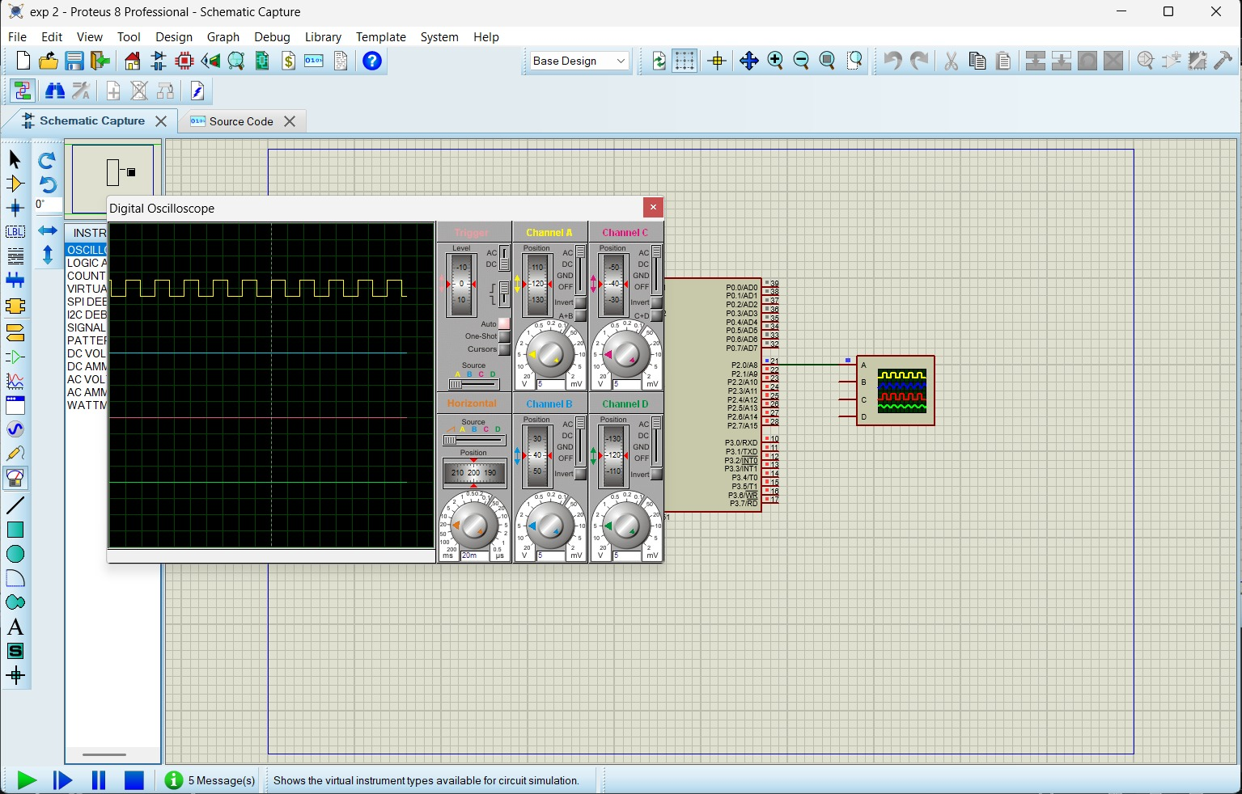

RESULT:
Thus the program has been successfully verified and executed.

